**What is Secure Software Development Life Cycle (SSDLC )?**

* The **Secure Software Development Life Cycle (SSDLC)** is a process to ensure that software is developed with a strong focus on security from the very beginning.
* It involves planning, designing, coding, testing, deploying, and maintaining software while consistently addressing security concerns at each step. SSDLC is crucial to identify and fix security issues early, reducing the risk of cyber threats.
* By integrating security measures throughout the development process, SSDLC aims to create safer and more trustworthy software applications.

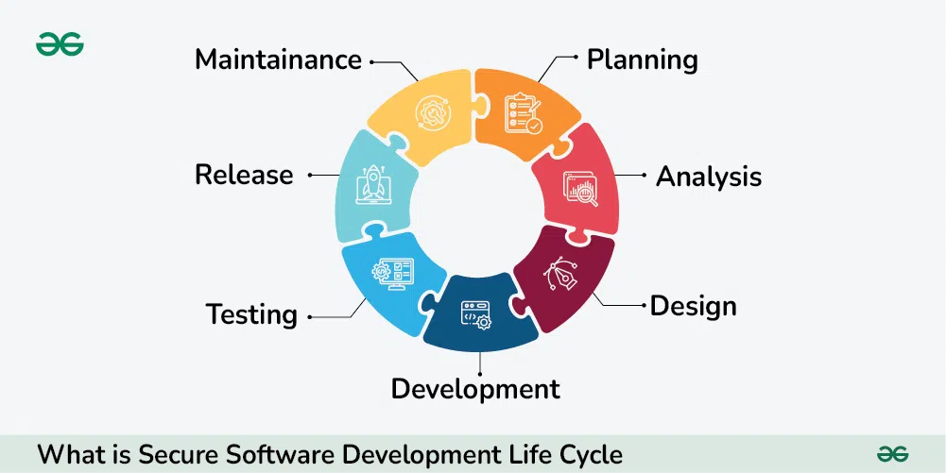

**Phases in SSDLC :**

**Planning**:

* This initial phase focuses on identifying the security requirements of the software.
* It involves understanding potential threats, vulnerabilities, and risks, and creating a security plan to address them.
* The goal is to ensure that security is a priority from the start, and appropriate resources and practices are allocated for it.

**Design**:

* During the design phase, the security requirements are integrated into the software’s architecture.
* Secure design principles are applied to build software that can withstand potential security risks. This includes deciding on encryption methods, authentication processes, and setting up access controls to protect sensitive data.
* The design should consider security as an essential part of the overall system architecture.

**Implementation**:

* In the implementation phase, developers start building the software using secure coding practices.
* This includes validating inputs, data validation, using proper error handling, and avoiding common coding mistakes that could lead to security breaches.
* Code reviews and peer reviews are conducted to catch any security flaws early in the development process.

**Testing**:

* The testing phase is dedicated to identifying vulnerabilities and weaknesses in the software.
* Various testing methods, such as penetration testing, static code analysis, and dynamic analysis, are employed to check for potential security flaws.
* This step makes sure the software is strong enough to handle security threats and works correctly even when attackers try to exploit it.

**Deployment**:

* After testing, the software is released to users. During this phase, we ensure that the release process is secure to avoid introducing new security problems when the software is launched.
* Steps like properly setting up servers, following secure coding practices, and applying necessary updates (patch management) are taken to make sure the software stays safe during and after deployment.

**Maintenance**:

* The final phase is ongoing and focuses on monitoring and maintaining the software over time.
* This involves keeping an eye on security and regularly updating the software to deal with new threats, making sure it stays secure over time.
* This includes tracking new vulnerabilities, applying patches, and updating the software to defend against emerging threats.
* Regular audits and vulnerability assessments ensure the software remains secure as new risks surface.

**Benefits of SSDLC:**

1. **Early Detection of Security Issues:**
   * Identifies and fixes security problems early in the development process.
2. **Reduced Costs:**
   * Fixing security issues early is cheaper than addressing them after deployment.
3. **Enhanced Trust:**
   * Produces more secure and reliable software, which increases user trust.
4. **Compliance:**
   * Helps meet regulatory and industry standards for security.
5. **Risk Mitigation:**
   * Reduces the risk of data breaches and cyber attacks.

**Key Challenges in SSDLC:**

1. **Complexity:**
   * Integrating security into every phase of development can be complex and time-consuming.
2. **Cost:**
   * Initial implementation and ongoing maintenance of security practices can be costly.
3. **Training:**
   * Requires developers and staff to be trained in security best practices.
4. **Resistance to Change:**
   * Teams may resist new security processes and practices.
5. **Constant Updates:**
   * Security threats evolve, so practices and software need continuous updating.